D479 Task A & B

1. Timeline

Activity Duration

|  |  |
| --- | --- |
| Review Documentation | 0.5 Day |
| Research | 0.5 Day |
| Create Persona | 0.5 Day |
| Create Wireframe | 1 Day |
| Guerilla Testing | 1 Day |
| Usability Testing | 1 Day |
| Update Prototype | 2 Days |
| Completed Presentation | 1 Day |

1. Persona Profile

**Name**: Caleb Sawyer  
**Age**: 35  
**Traveling with**: Partner and 2 children  
**Lives**: Denver, Colorado  
**Occupation**: Software Developer  
**Salary**: $70,000

**Attitude to Technology**:  
Caleb is enthusiastic about technology and relies heavily on his smartphone and laptop for both work and leisure. He uses travel apps to organize itineraries and often shares moments from his trips on social media. He values tech solutions that simplify family travel logistics.

**Context of Use**:  
Caleb uses his smartphone to navigate Taniti’s attractions, book activities, and check restaurant reviews. He prefers tools that integrate maps, schedules, and reviews to streamline travel planning.

**Key Driver(s)**:  
Discovering unique cultural experiences, enjoying family-friendly outdoor adventures, and fostering family bonding through shared activities.

**Objectives**:

* Exploring beaches and hiking trails suitable for children
* Finding accommodations that offer both comfort and family-oriented amenities
* Enjoying a mix of local and international cuisines
* Accessing real-time updates on events and attractions

**Challenges**:

* Inconsistent internet connectivity in rural areas
* Difficulty finding kid-friendly restaurants and activities that cater to diverse ages
* Managing transportation and schedules effectively

**Biography**:  
Caleb is a detail-oriented software developer who loves spending quality time with his family. He and his partner prioritize travel to introduce their children to diverse cultures and natural wonders. Caleb’s love for the outdoors aligns perfectly with destinations like Taniti, offering beaches, rainforests, and volcanoes. His analytical mindset ensures well-organized trips, but he enjoys spontaneous moments, too. He seeks destinations where his family can relax and explore without compromising safety or accessibility. As someone who values efficiency, Caleb uses apps and digital tools to enhance their travel experience.

**Source:** Migneault, L. (2020, May 21). *Photo by Ludovic Migneault on unsplash*. Man in gray button up shirt photo – Free Man Image on Unsplash. https://unsplash.com/photos/man-in-gray-button-up-shirt-EZ4TYgXPNWk

1. 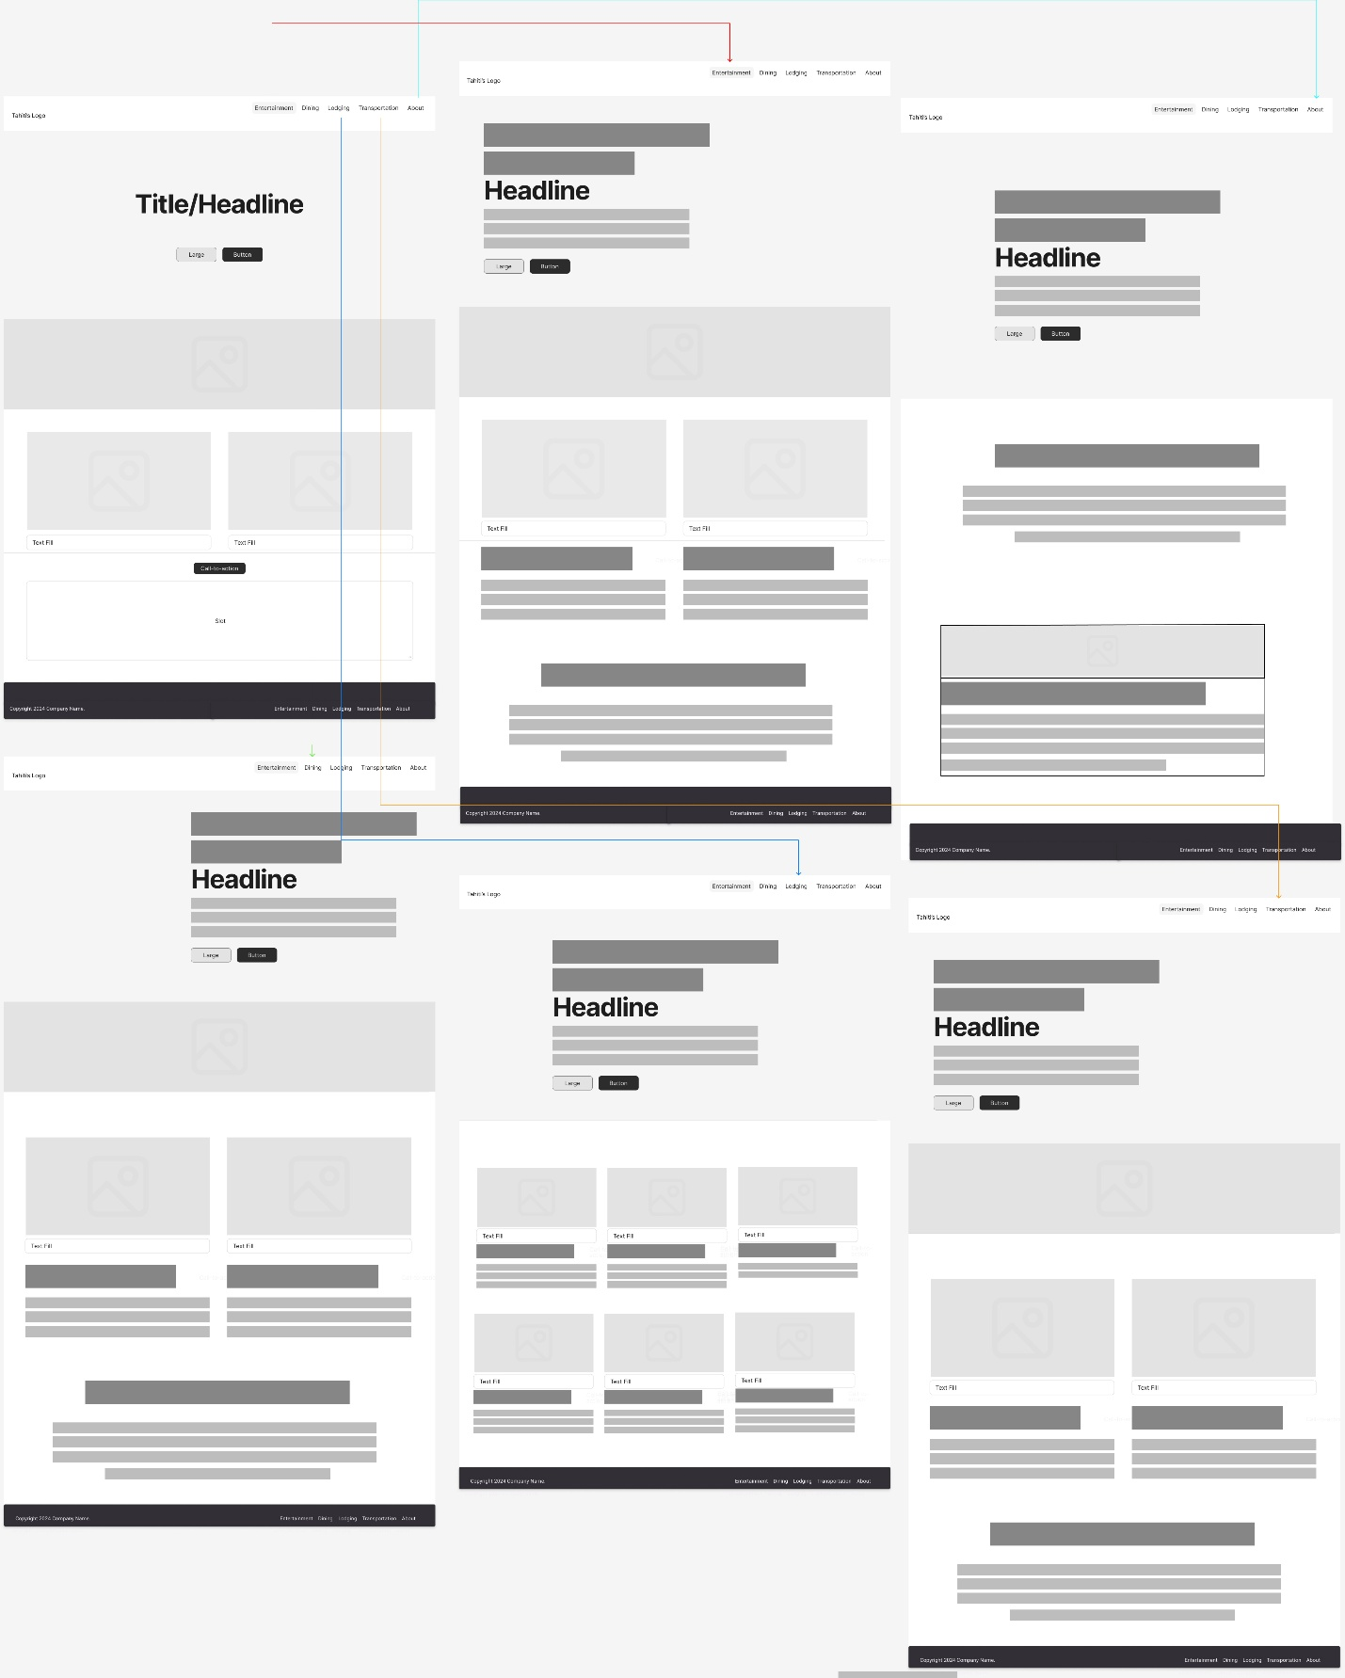Wireframe